A000-ME-Sumerian-Chalice-Limestone-Late Uruk-Jemdet Nasr Period, c 3100-2900 BCE

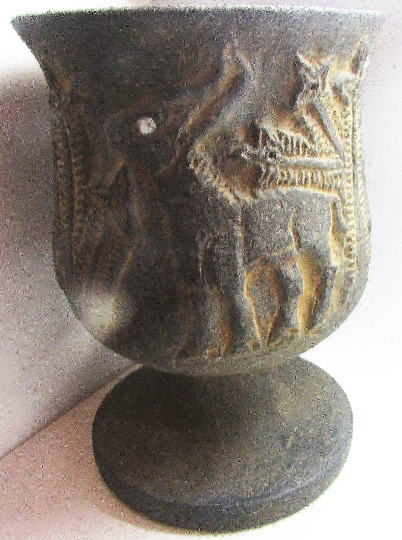 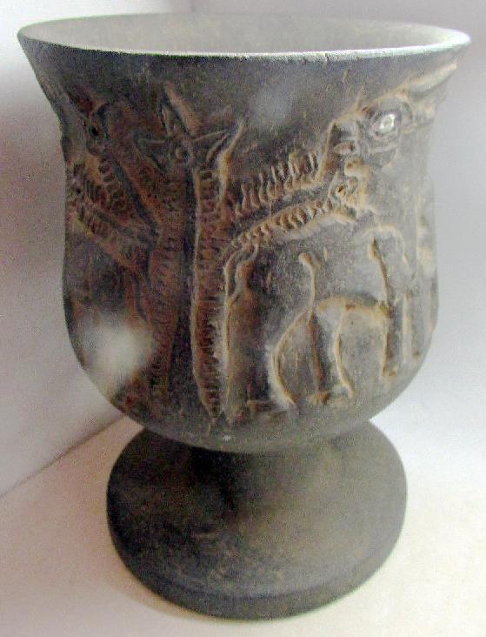 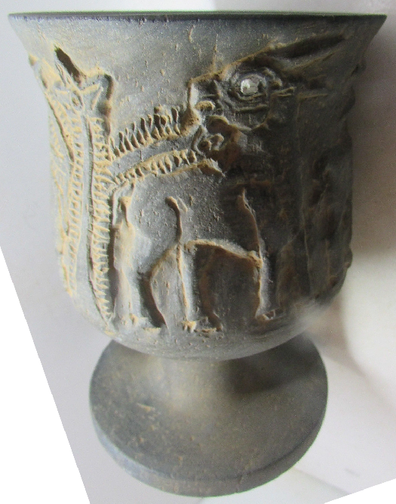 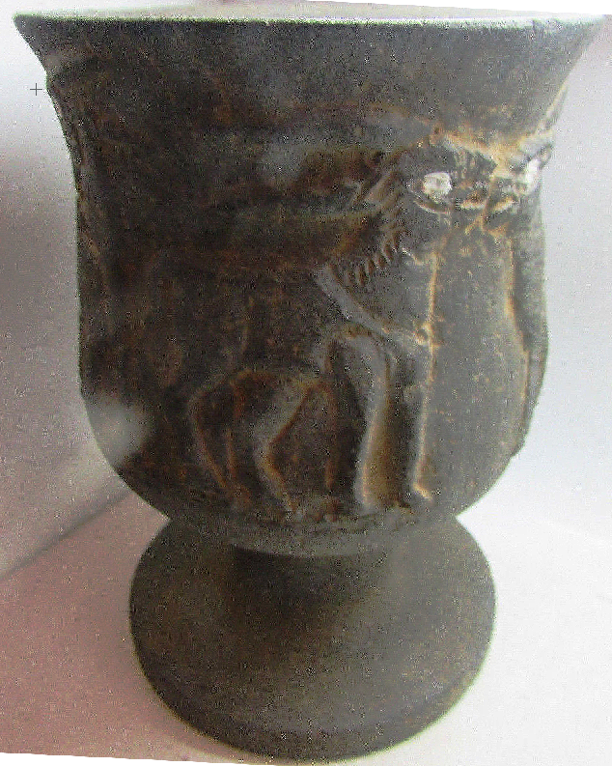 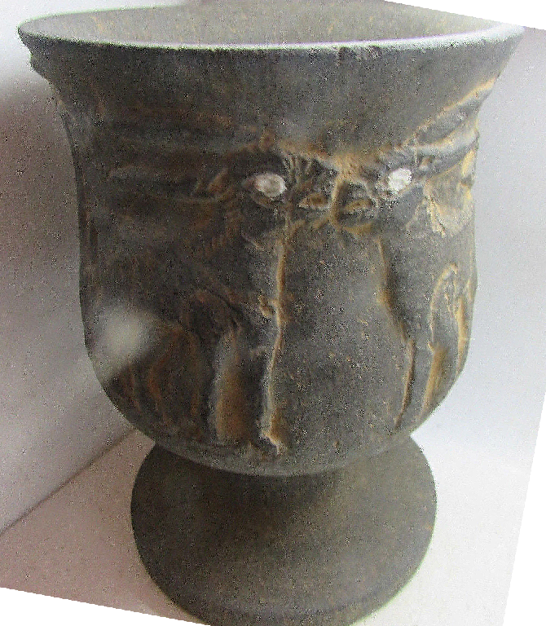

Figs. 1-5. Sumerian-Chalice-Limestone-Late Uruk-Jemdet Nasr Period, c 3100-2900 BCE 14.7 CM HIGH

**Case No.: 2**

**Accession No.**

**Formal Label:** Sumerian-Chalice-Limestone-Late Uruk-Jemdet Nasr Period, c 3100-2900 BCE

**Display Description:**

**Accession Number:**

**LC Classification:**

**Date or Time Horizon:**

**Geographical Area:**

**Map:**

**GPS coordinates:**

**Cultural Affiliation:**

**Media:**

**Dimensions:**

**Weight:**

**Condition:**

**Provenance:**

**Discussion:**

**References:**

This chalice is set on a flat base, with the sides boldly carved in raised relief.

This chalice is decorated with a procession of 4 bulls 2 moving to the right and 2 to the left. This iconography is typical of the Late Uruk and Jemdet Nasr periods at the end of the fourth millennium BCE when cities were developing in Mesopotamia. Three-dimensional carving of bulls appears to suggest that the development of animal husbandry was becoming very important for the economies of individual city-states in the Mesopotamian delta where this chalice as found. Vessels of this type have been found in palaces or religious structures, which suggests that they had a ceremonial function. This appears confirmed by the axial placement of the Tree of Life placed in the procession so as to reflect the procession of life from it one of the major spiritual ideas of the time.

**Background:**  Uruk was dedicated to two great gods, An (or Anu) the sky god and Inanna or Semitic Ishtar, the goddess of love and procreation, whose vast temple complex E-Anna (the house of heaven) dominated the city. Stone vessels of this type - highly prized luxury goods made of imported stone and carved with great skill - date to the late Uruk period were often found in temples or palaces. Chalices such as this are thought to have been made for ceremonial use in temples (the mythical animals known from cylinder seals may be associated with cults espousing politicization of a region. Inanna's husband Dumuzi-Tammuz was closely associated with vegetation, flocks and cattle and the cult of the sacred marriage between them, with its associated rites designed to ensure productivity and fertility, originated at Uruk.  
For a similar stone bowl decorated with bulls see, J. Aruz (ed.), *Art of the First Cities*, exhibition catalogue, The Metropolitan Museum of Art, New York, 2003, p. 42, no. 12, for a stone bowl with bulls in relief in the Vorderasiatische Museum, Berlin, no. VA 10113; "The considerable work involved in creating stone vessels and the fact that the stone was imported gave them great value. While fragile ceramic vessels had to be continually replaced and therefore likely to reflect changes in taste ... stone vessels tended to be produced in a limited range of shapes and to be used for generations."